For Immediate Release
January 8, 2018

SINGER/ACTRESS UTE LEMPER RETURNS TO CAFÉ CARLYLE, FEBRUARY 27-MARCH 3
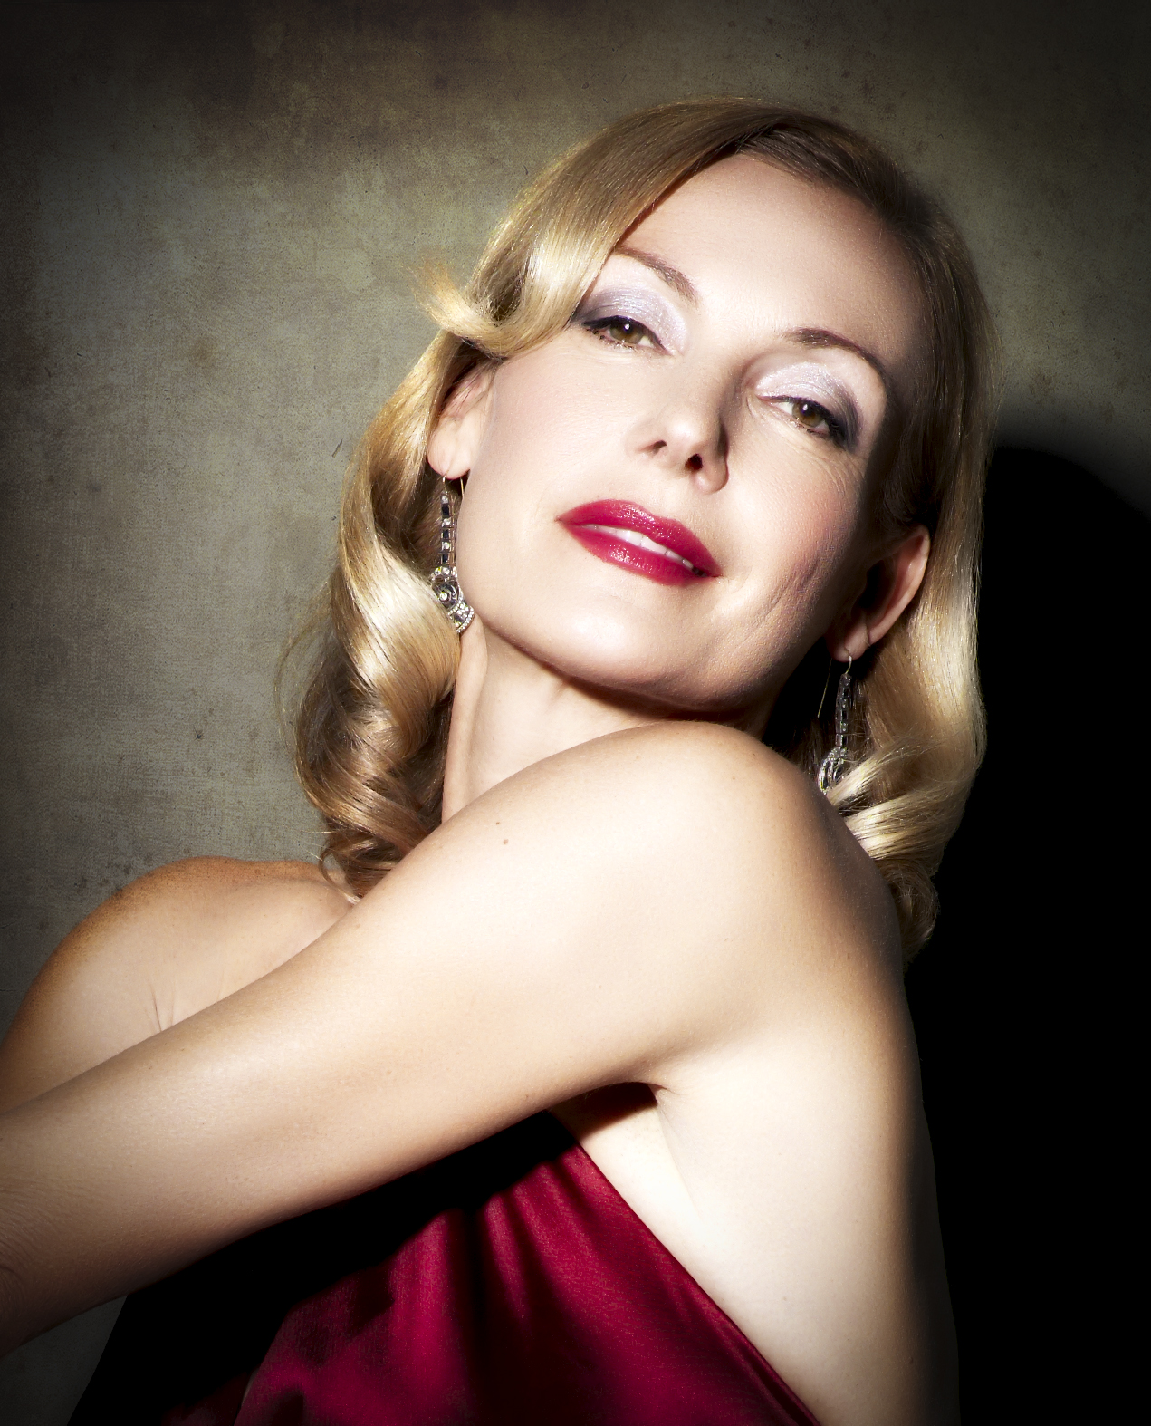
Ute Lemper returns to Café Carlyle with an all-new show, Rendezvous With Marlene, February 27 – March 3. Rendezvous With Marlene is based on a 3-hour phone call and exchange between Marlene Dietrich and Ute in 1988. After receiving the French Molière Award for her performance in Cabaret in Paris, Ute had sent a postcard to Marlene, who had lived at 12 Avenue de Montaigne since 1979, essentially apologizing for all the media attention comparing her to Marlene Dietrich. Ute was just at the beginning of her career in theatre and music, whereas Marlene looked back on a long, fulfilled life of movies, music, incredible collaborations, love stories and stardom. Ute considers it a secret gift to have heard Marlene talk about her life, her work and style, her love for the poet Rilke, her complicated relationship with Germany, her sorrow and her fascinations.

Six days before Ute’s opening night playing the part of Lola in the 1992 Blue Angel production in Berlin – the role that had made Marlene a star in 1928 – Marlene Dietrich passed away in Paris. After her glamorous funeral in La Madeleine, Marlene finally came back to Berlin to be put to rest. Ute tells us Marlene's story along with singing songs from all chapters of her life -- from the Berlin Cabaret Years to her fabulous Burt Bacharach collaborations.

Now 30 years later, after her own extensive international career and also complicated relationship with her home country Germany that she only returns to for concerts, and living the last 30 years between New York, London and Paris, Ute reflects with humor and depth on that unique moment with Marlene.

Performances will take place Tuesday – Saturday at 8:45pm. Weekday pricing begins at $65 per person / Bar Seating: $40 / Premium Seating: $115. Weekend pricing begins at $80 per person / Bar Seating: $50 / Premium Seating: $130. Reservations can be made by phone at 212.744.1600 or online via Ticketweb. Café Carlyle is located in The Carlyle, A Rosewood Hotel (35 East 76th Street, at Madison Avenue).

Ute Lemper’s career is vast and varied. She has made her mark on the stage, in films, in concert and as a unique recording artist on more than 30 albums over an esteemed 30-year career. She has been universally praised for her interpretations of Berlin cabaret songs, the works of Kurt Weill and Berthold Brecht and the Chansons of Marlene Dietrich, Edith Piaf, Jacques Brel, Léo Ferré, Jacques Prévert, Nino Rota, Astor Piazzolla, her own compositions, as well as her portrays in musicals and plays on Broadway, in Paris, Berlin and in London’s West End.

Follow Ute Lemper on Facebook, Twitter and Instagram.
Follow Café Carlyle on Facebook, Twitter and Instagram.
About Café Carlyle at The Carlyle, A Rosewood Hotel
Originally opened in 1955, Café Carlyle is New York City’s bastion of classic cabaret entertainment, a place where audiences experience exceptional performers at close range in an exceedingly elegant setting. Since composer Richard Rodgers moved in as The Carlyle’s first tenant, music has been an essential part of The Carlyle experience. No place is that more evident than in the Café Carlyle.
Café Carlyle is known for talents including Woody Allen, who regularly appears on Monday evenings to play with the Eddy Davis New Orleans jazz band. For three decades, Café Carlyle was synonymous with the legendary Bobby Short, who thrilled sell-out crowds for 36 years. His spirit lives on through the music at Café Carlyle.
Continuing the tradition of the 1930s supper club, Café Carlyle features original murals created by French artist Marcel Vertès, the Oscar-winning art director of the 1952 Moulin Rouge.
American Airlines in-flight magazine, American Way, recently included Café Carlyle within their 2017 Platinum List as one of the Top 3 Music Venues in the World.

For more information, please contact Matt Gross at Blake Zidell & Associates, 718.643.9052, matt@blakezidell.com.

